Lab 12

Lab Tasks
Name : saqba Yasmin
Sap Id : 63476
Submitted to: Maam Rehana Sanam

Task : 1

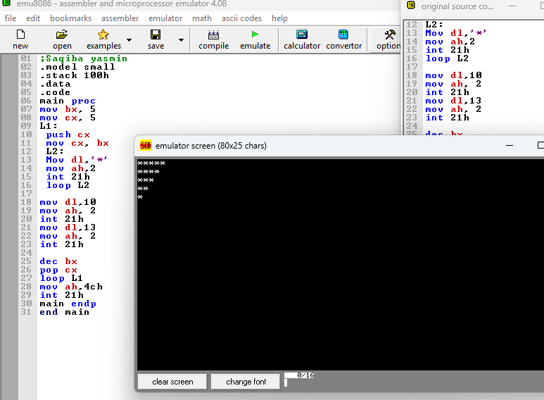

Task : 2

